Instructions for Running ScalaBuild.

Run the scalabuild.jar file with the java command.

$ java -jar scalabuild.jar

\* Enter he Scala Play! Directory.

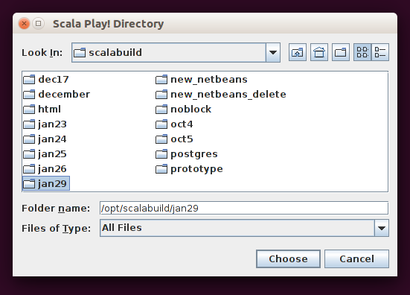

\*

Enter the location of the DDL sql file that contains the Create Table statements used to build the application.

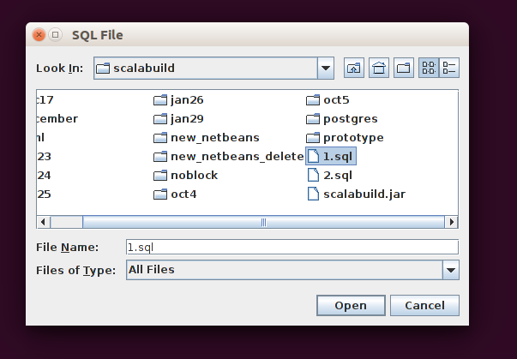

\*

ScalaBuild will read all the tables which have Create Table statements and present them in this next screen.

The All Tables box contains all of the tables read from the SQL file.

To Add or Delete from the Table List

\* The Selected Tables originally contains the same set of tables which can deleted by selecting a table in the All Tables list and selecting the Table Delete button.

\*

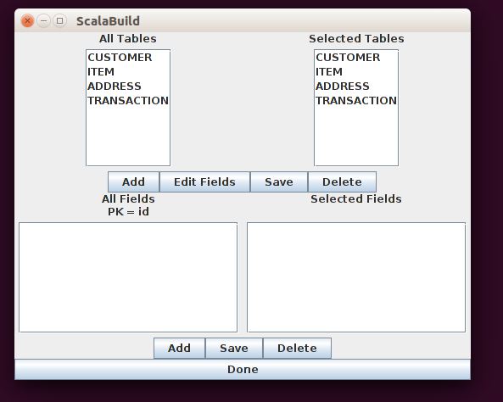

Deleted tables can be re-added by selecting the table in the All Tables list and selecting the Table Add button.



To Add or Delete fields from a Table\

NOTE: The Primary Key field can not be deleted since it is necessary for building the Scala code per table as well as the Scala code for joins. The primary key is shown beneath the Fields labels and can not be edited. ( The example shows the primary key as ‘id’ ).

\* Select the table in the Selected Tables list.

\* The fields will show in both of the All Fields and Selected Fields lists.

\* To Delete a field select the field in the Selected Fields list and select the Delete button.

